PREDICTING THE ENERGY OUTPUT OF WIND TURBINE BASED ON WEATHER CONDITIONS USING IBM CLOUD

Applied Data Analytics

Done by:

**Hrithik Mitra - 18BEI0156**

**Rishitha Tamma - 18BCD7116**

**Soumya S. Nair**

**Tripti Mishra - 18BCE0888**

**INDEX**

1.Introduction

1. Overview
2. Purpose

2. Literature Survey

1. Existing Problem
2. Proposed solution

3. Theoretical Analysis

1. Block Diagram
2. Hardware/Software designing

4. Experimental investigations

5. Flowchart

6. Result

7.Advantages & Disadvantages

8. Applications

9. Conclusion

10. Future Scope

11. Bibliography

12.Appendix

1. Source Code
2. UI output screenshot
3. **INTRODUCTION**
4. Overview:

Wind power generation differs from conventional thermal generation due to the stochastic nature of wind. Thus wind power forecasting plays a key role in dealing with the challenges of balancing supply and demand in any electricity system, given the uncertainty associated with the wind farm power output. Accurate wind power forecasting reduces the need for additional balancing energy and reserve power to integrate wind power. For a wind farm that converts wind energy into electricity power, a real-time prediction system of the output power is significant. In this project, a prediction system is developed with a method of combining statistical models and physical models. In this system, the inlet condition of the wind farm is forecasted by the auto regressive model.

1. Purpose:

Since, the demand of wind power is increasing day by day, it is necessary to know what are the different factors which are necessary for generating a good amount of wind energy. From our dataset we came to a conclusion that Active power and Wind Speed are the two major factors which contribute to efficient wind energy (i.e., theoretical power curve). The purpose of our project is that any layman can use our website and enter the values of active power and wind speed and get the corresponding energy which will be generated from those values. By adjusting the active power, the person can get the theoretical power curve. Along with the theoretical power the person can look for the climatic conditions in their area. They just have to enter their city name and a detailed analysis of climate will be presented on the screen. Here, the wind speed will also be displayed. This wind speed can be entered when looking for a particular thermal power.

**2. LITERATURE SURVEY**

a. Existing problem:

Now, meteorologists have to manually take down every value and then calculate the value for theoretical power. This is a very time taking process and there are chances for human errors. As this decides how much energy will be produced, any kind of error will cost a huge amount to the government. Also, there is no fixed formula for calculating Theoretical power. They depend on a number of factors. Hence, we have to come up with a solution such that the work for meteorologists is decreased and also efficiency is increased.

b. Proposed Solution:

We need a model which will take Active power and Wind speed as input and give us Theoretical power as output. Since, Theoretical power is continuous in nature this can be classified as a regression problem. We will use various regression algorithms for building our model. The algorithms included in our project are Decision Tree regressor, K-nearest neighbours, Random Forest and Linear Regression. Among these whichever algo gives the best accuracy we will use it for building the model. We will be creating a user-friendly UI where the user can enter the Active energy and Wind speed and it will show us the corresponding Theoretical power. Also, when the user enters the city name, climatic condition will be shown to him of the respective location. In this way, the user's problem will be solved.

**3. THEORETICAL ANALYSIS**

# a.Block Diagram

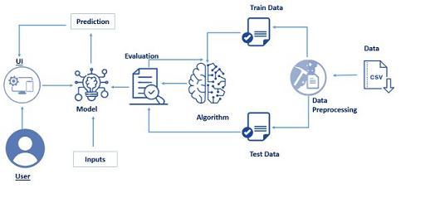

# b.Hardware/Software Requirements

* Cloud Tool used : IBM
* IDE : Jupyter Notebook , Spyder , Anaconda navigator
* Dependencies Required : Keras, Tensorflow, OpenCV
* Programing Language(Back-end) : Python 3.7
* Front-end : Html /css
* Framework : Flask

**4. EXPERIMENTAL INVESTIGATIONS**

* The dataset which was provided had 5 columns namely Date/Time, Lv Active Power, Windspeed, Theoretical power curve and wind direction.
* While analysing the we came to a conclusion that only Lv active power, Windspeed and Theoretical power curve are the major factors.

Power production vs wind speed scatter plot:

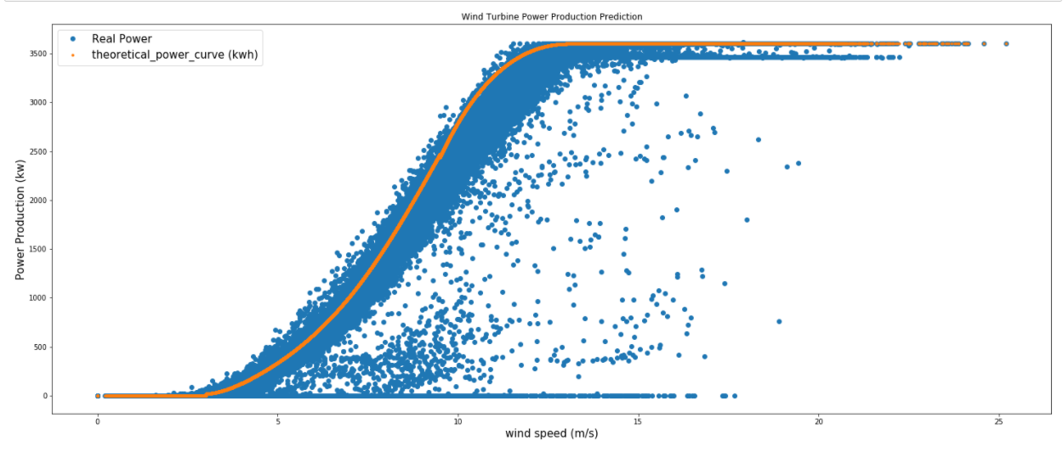

* Among these Theoretical power curve was our dependent variable because goal of our project is to predict energy.
* The independent variables are Lv active power and Windspeed.
* There were no null values in the dataset.
* Outliers were removed by z-score.
* Standard scaler was used for normalizing the inputs.
* Since Theoretical power curve is a continuous variable we have used different regression algorithms for model building purpose.
* We found that Random forest was having the highest r2_score hence we used this algorithm to train our dataset.
* 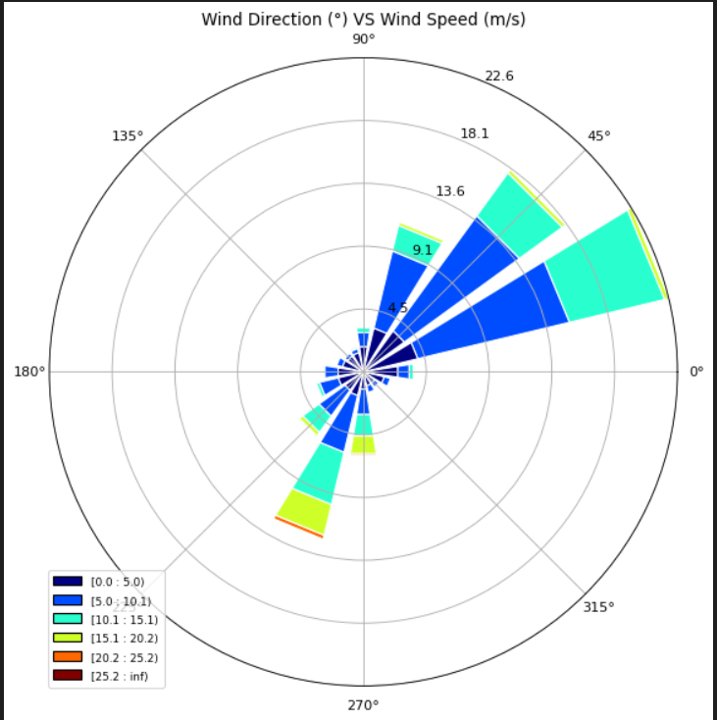

Scatter plot of wind speed vs wind direction:

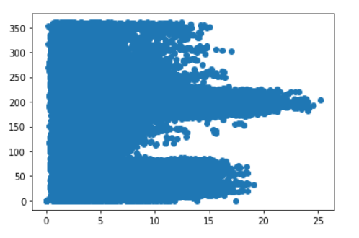

**5. FLOW CHART**

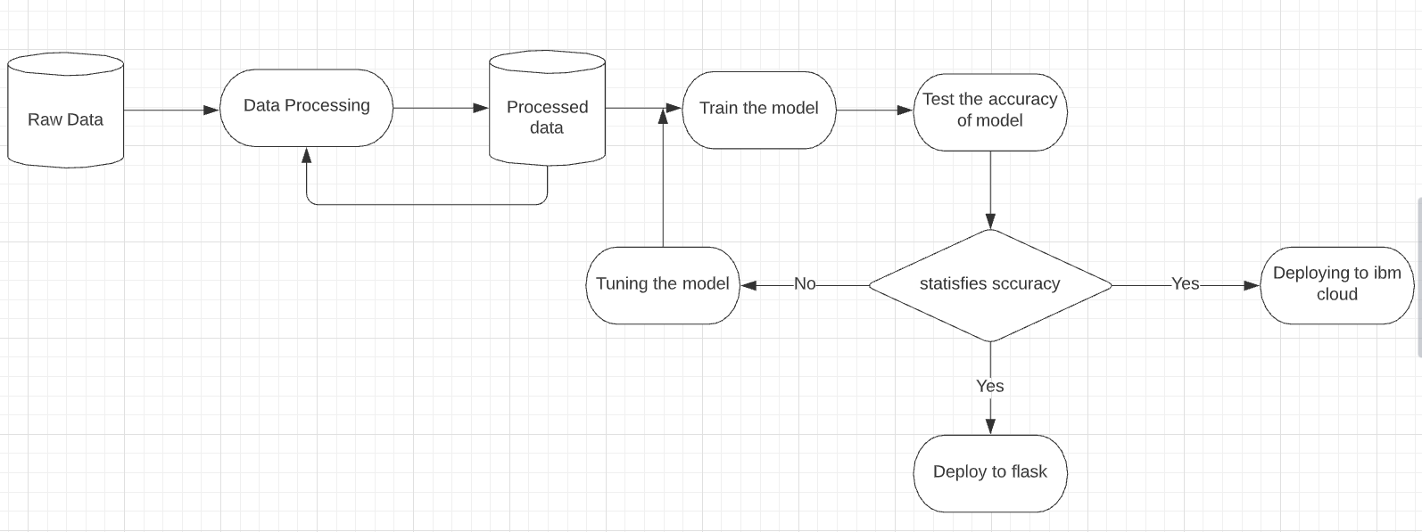

**6. RESULT**

This is our UI interface. Here, our user can select any of the states from India and then he will get the current climatic conditions in that region. These conditions include temperature,humidity, pressure and wind speed. Next to that we can see a tab for predicting wind energy. Here we have to enter the Active power and wind speed, in return we will get the Theoretical power i.e. the wind energy. As people are more inclined towards non-conventional energy, this UI will help them to find how much energy will be generated and accordingly user can plan their future steps.

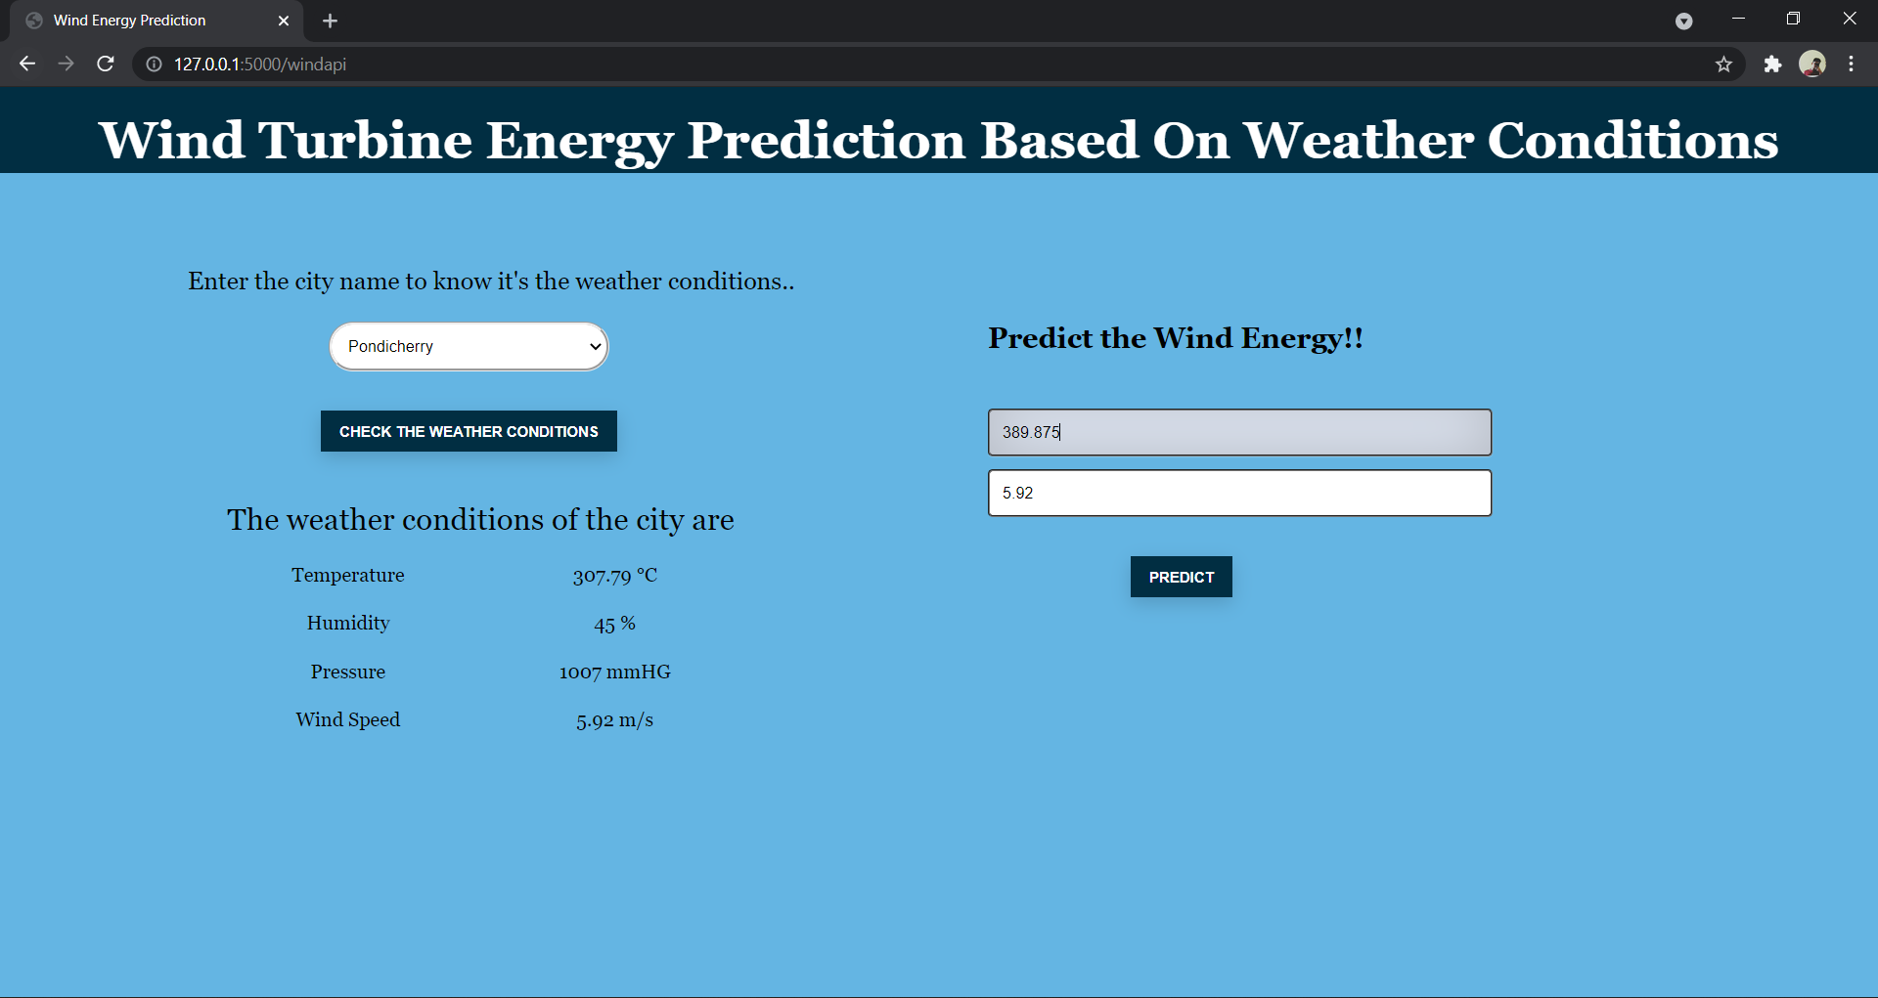

**7. ADVANTAGES**

1. Reduces man power.
2. Companies can deploy to improve their energy harnessing efficiency.
3. Easy to use & has a user friendly interface.
4. The dataset maintained can allow companies to easily monitor the access(users).
5. The weather conditions analysis that are not manually answered are responded to by the Web Dashboard.
6. Results can be improved by training data to our choice of parameter.
7. Weather analysis at different sites need not to be monitored.
8. Can be used in areas with less connectivity as well.
9. Cost efficient.
10. Is an alternative source of energy which uses clean & green fuel.

**DISADVANTAGES**

1. Some complex integration of services are required.
2. Requires some complex integration of services.

**8. APPLICATIONS**

1. Companies can use the services & deploy it on their own servers.
2. Time saving & cost efficient method as many applications are not needed to implement.
3. The service can be provided to users in application along with other features.
4. Even in areas with less connectivity, the application can be used.
5. As the application is quite robust & resilient in its architecture, it allows us to easily navigate through different sections.

**9. CONCLUSION**

We, hence successfully created an interactive energy prediction dashboard using Watson studio,Watson Machine Learning,Weather Data.The experimental investigations showed the integration of different IBM cloud services. The results show that the responses from the Application were relevant.

Although, the Web Applications needs complex integration of services, it can be deployed easily to leverage the energy prediction and improve the energy production effectively.

**10.FUTURE SCOPE**

1. We can try to achieve better predictions by considering other parameters like humidity, wind direction and climate changes.
2. On-device model can be developed to make much more faster predictions
3. The model can be developed to make predictions on other sources of data like solar energy, tidal energy etc.

**11. BIBLIOGRAPHY**

[1] Weather api - <https://openweathermap.org/current#cityid>

[2] Importance of wind energy- https://www.researchgate.net/publication/326340286_Wind_Energy_A_Review_Paper

**12. APPENDIX**

# a.Source code

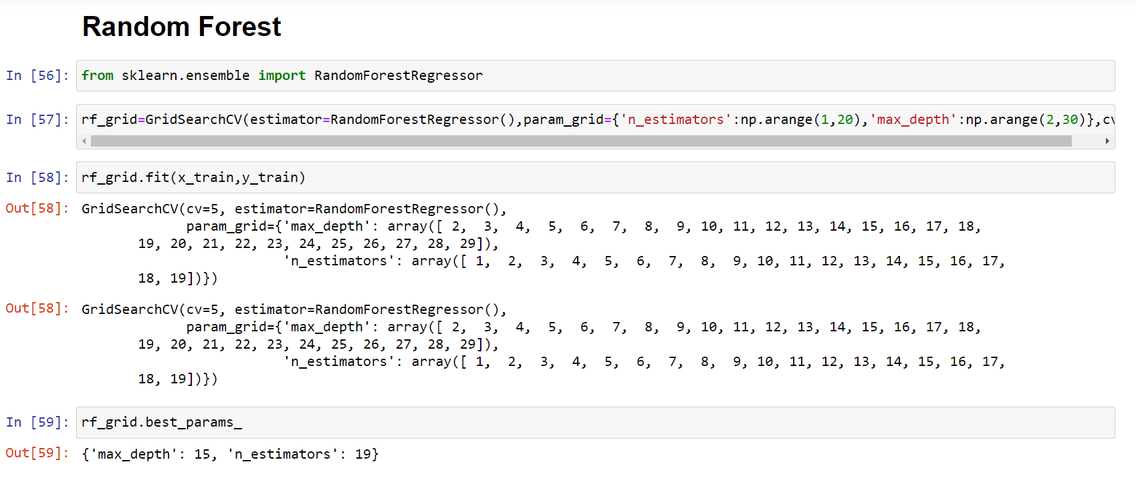

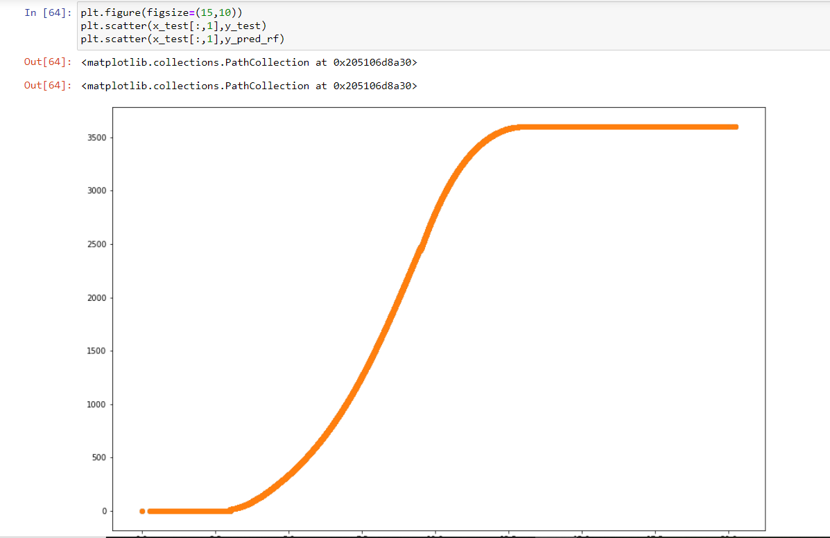

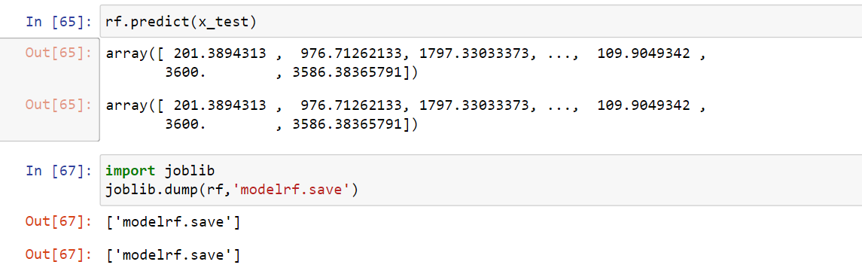

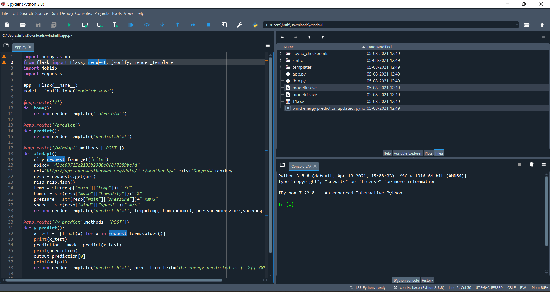

## 

## b.UI output screenshot

